Business Process: AMI Billing Export (ABE)

Contact | Contact Person
Business Process Owner | Billing Exception Management
Subject Matter Expert(s) | Jose Ortega, Sarah Plowden, Janee Baltimore
Key Contact | Carol Cerqueda
Key User(s)/Role | Billing Exception Management CSRs, Sr. CSRs, Revenue Analysts
Date Documented | 02/07/2016

Business Process Overview
The AMI Billing Export (ABE) process calculates and exports Bill Determinants from Itron Enterprise Edition (IEE) to SAP for billing and invoicing. The ABE process is scheduled to start daily at 9:00 AM, triggered by SAP Control-M jobs

Prerequisites and/or Dependencies
- IEE receives a billing determinant request from SAP

Business Process Assumptions
(Assumptions pertaining to the business process)
Process | - IEE will receive Billing Determinant requests
People | - Billing Exception Management CSRs, Sr. CSRs, and Revenue Analysts
Technology | - IEE  - UIQ  - SAP

Process Flowchart
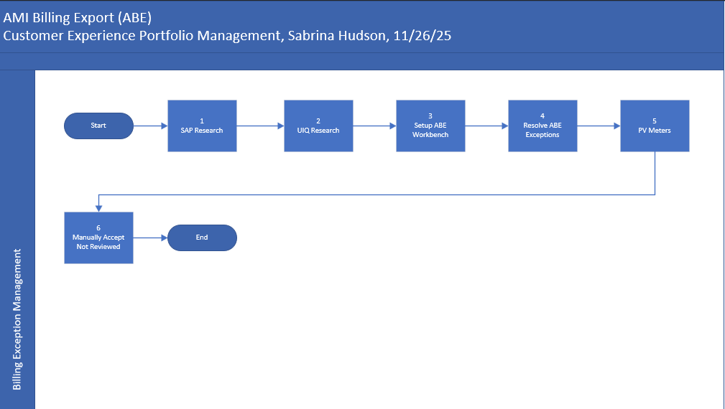

Task Description
Id | Task Description | Procedure
1 | SAP Research | - Access SAP transaction ZCSBH to determine what issues may have occurred to create an ABE exception  - Enter Installation, Premise, or Device # and click Enter  - Double click on the Device Location  - Click the Editor icon  - Review the Device Location notes for reasons that explain an exception – review the latest notes  - Click back arrow 2x  - On ZCSBH screen, click on Contract  - Click on Customer Overview link  - Click on the Service Notifications link  - Click on target Service Notification, then click the green checkmark  - Research Service Notifications (SNs)(Can use CIC0 for research)  - Click on the “X” to close the SN list  - On Customer Overview Screen, click on the Contact Logs link  - Click on the target Contact Log, then click the green checkmark  - Review Contact Logs (Can use CIC0 for reviewing contact logs) to determine if customer contacted SMUD – review Contact Logs closest to the date of the exception  - Click the “X” to close the Contact Log list  - Access SAP transaction IW59
2 | UIQ Research | - Work performed in UIQ – See process and procedure documentation for detailed steps
3 | Setup ABE Workbench | - Work performed in IEE – See process and procedure documentation for detailed steps
4 | Resolve ABE Exceptions | - Work is performed in IEE – See process and procedure document for detailed non-SAP steps
5 | PV Meters | - For active meters, check bill determinants  - Access SAP transaction ZCSBH  - Right click on the installation number and select copy  - Click on Meter Monitoring  - Click on Installation and paste installation number  - Click on Bill Determinants, then click the Execute icon  - Click back arrow to return to the ZCSBH screen  - From the ZCSBH screen, add a Bill Block  - Highlight the contract account and click the pencil  - Click on page 2 and add bill block reason 04  - Click the Save icon  - Add a device location note of the issue with follow-up date and bill block reason  - For exceptions caused by duplicated intervals ensure you: Create a Meter Test SN  - Login to CRM to request a meter test  - Enter Contract Account # and click Enter  - Click on the Service Notification Workcenter  - Highlight the meter # to select  - Click the dropdown for category and select 0008 Meter & Service Request  - Click the dropdown for activity and select 0015 District Req for Meter Test, Possible Ma  - Add notes in Remarks section  - Click the Save icon
6 | Manually Accept Not Reviewed | - Manually accept exceptions that cannot be billed  - In IEE, manually accept exception “Exception Not Reviewed”  - Open SAP transaction ZCSBH  - Click on the contract, then click the pencil  - Click on page 2  - Add bill block reason 04  - Click the Save icon  - On ZCSBH, click the device location, then click the pencil  - Click on the editor icon  - Add a Device Location note noting the issue, follow-up date, and bill block reason  - Example: (BEM NTABAY 3/1/2024 BILL BLOCKED DUE TO PENDING METER WORK SN 1234567 F/U 4/3/2024.)

Business Rules
Id | Event Name | Business Rules
4 | Resolve ABE Exceptions | - ABE exceptions must be completed promptly and take priority over all other work assignments  - It is critical to resolve all ABE exceptions in a timely manner because a single unresolved exception can hold up the entire batch of request items due to batch processing  - Immediately submit your completed ABE MDUS Worksheet to the Billing.Systems@smud.org inbox without delay upon finishing your ABE assignments  - No configuration changes, such as change meters, new sets, or similar modifications are permitted during the ABE operation window  - Also avoid requesting bill determinants during the ABE window  - Whenever you import, edit, or estimate data in IEE, resubmit bill determinants for reprocessing and manually accept them  - Before manually accepting an ABE queue item, verify that Bill Determinants exists unless manual acceptance is intended solely to remove the request from the queue  - Manually accepting a queue item without bill determinants will cause bill determinants with exceptions to be exported to SAP  - All pending meter work must be thoroughly reviewed and resolved

Event | Legal Requirements (Optional)  Legal documents/ procedures/ requirements to be fulfilled before/at the specified event.
Id | Event | Legal Requirements
N/A

PART B – Formal System Changes

Technical Requirements
Id | Event Name | Requirement
N/A

Itron/SAP/SSN/Other (Optional)
Undertaking Doc. No. | Date submitted | Date approved | Undertaking description
Doc ID as assigned by project(BTSR, Altiris ticket #, etc. |  |  | Description of task to be undertaken.

PART C – Change Management & Training

Departments impacted by process change (Required)

Department | Type of Change(s) | Action Required
N/A

End User Training Impacts (Required)

End User Audience | Training Required | Training Delivery Method | Timing/Dependencies
None

PART D – Process Controls and Document Tracking

Process Tracking
(For each Event, identify relevant measurements, occurrences, frequencies, etc.)
Id | Event Name | Metrics
4 | Resolve Abe Exceptions | - ABE Exceptions must be resolved by 12:30pm daily

Supporting Documentation
(Any subsequent documentation in support of this business process (i.e. business requirements, technical specs, etc.) shall be summarized in the following table.)
Document Type | Author | Link

Stakeholders
(Required signatures for all stakeholders of this process)
Name | Job Title | Department | Date
Carol Cerqueda | Supervisor | Billing Exception Management

Business Blueprint Amendments

Any subsequent changes to this business process blueprint after the official document approval shall be summarized in the following table. This document must be reprinted and signed by the authorized representatives.
Version | Author | Description of Change | Approval (Name/Sign) | Date
v.0 | Tina Dorsette | Documentation of to-be process.
v.1 | Sabrina Hudson | Update process flow, contacts, SMEs, process tasks and business rules |  | 11/26/25

